­Assignment 2

1. WAP to find roots of a quadratic equation (for D>=0 case).

2. WAP to format console output using '\n', '\t', '\b' within printf statement.

3. WAP to utilize assignment **+=** and **-=** type operators.

4. Verify the difference between increment operator i++ and ++i.

5. Assignment operator assigns right hand side value to left hand side variable. Use this idea to interchange (swap) values of two variables. (Hint: You may need a third variable. Think like switching coffee and tea between two cups using a third cup)

6. WAP to shift left and shift right operators (>> and <<).

7. WAP to utilize ternary operator.

8. WAP using sizeof() function to find size of char, integer, long int, float and double

9. WAP to divide two numbers and use type casting operation (e.g. mean = (double)sum/n;)

10. String is set of characters (one next to each other stored in the memory and not related to each other), e.g. ="abc123". WAP to practice type casting using the following functions. You can initialize a string using statement char \***s**="3.145" Then **s** is a string.

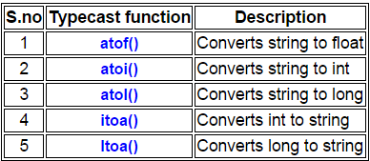

11. WAP to illustrate all four storage classes (auto, static, register, extern).